**RV COLLEGE OF ENGINEERING®**

**BENGALURU – 5600591**

**Experiential Learning Report**

Project-Based Learning

**2024-25**



**Title of the Project**

**AI-Based Digit Recognition for Automotive Domain: Fake Number Plate Recognition**

**Student(s)**

|  |  |
| --- | --- |
| **USN** | **Name** |
| 1RV22CD028 | Medha Mummigatti |
| 1RV22CD060 | T Keerthi Amudaa |
| 1RV22CD066 | Joel Stephen Matthew |
| 1RV22CY007 | Aditya S Nair |
| 1RV22CS119 | Mohith S |

**Mentor**

|  |
| --- |
| **Name, Designation & Department** |
| **Dr S Anupama Kumar**   Associate Professor,  Department of Artificial Intelligence and Machine Learning,  R V College of Engineering |

RV COLLEGE OF ENGINEERING®

BENGALURU – 560059

(Autonomous Institution Affiliated to VTU, Belagavi)

# 



**CERTIFICATE**

It is certified that the Experiential Learning work titled “AI-Based Digit Recognition for Automotive Domain: Fake Number Plate Recognition” has been carried out by Medha Mummigatti(1RV22CD028),T Keerthi Amudaa(1RV22CD060),Joel Stephen Matthew

(1RV22CY031),Aditya S Nair(1RV22CY007) and Mohith S(1RV22CS119)

who are bonafide students of R.V College of Engineering, Bengaluru, during the third semester, in the year 2024-2025. It is also certified that all corrections/suggestions indicated for the Internal Assessment have been incorporated into the report. The report has been approved as it satisfies the academic requirements in respect of experiential learning.

**Marks Awarded:**

# 

**Head of Department**

Department of CSE,

RVCE, Bengaluru–59

# **ACKNOWLEDGEMENT**

I would like to express my sincere gratitude to **Dr. K N Subramanya** and **Dr S Anupama Kumar** for their invaluable insights and guidance throughout the development of this project. Their expertise and support have played a crucial role in shaping the conceptual and technical aspects of our **AI-Based Digit Recognition for Automotive Domain: Fake Number Plate Recognition**.

I extend my heartfelt appreciation to **Dr.Pratiba.D** for their constant encouragement and valuable feedback. Their guidance in structuring this project and aligning it with our academic curriculum has been instrumental in refining our approach.

I am also grateful to **R V College of Engineering** for providing the platform to explore innovative solutions and enhance our technical skills. Additionally, I acknowledge the support of my friends and peers, whose motivation and constructive feedback have been vital in overcoming challenges.

Lastly, I appreciate the collective efforts of educators and researchers working towards improving digital learning and assessment methodologies. This project is a step toward making the evaluation process more efficient, insightful, and student-friendly.

R V College of Engineering

07-02-2025

# **ABSTRACT**

The increasing prevalence of fake number plates poses significant challenges to law enforcement agencies and vehicle registration authorities, enabling fraudulent activities such as vehicle theft, illegal transportation, and traffic violations. Traditional methods of number plate verification are manual, time-consuming, and prone to human error, necessitating the development of an automated and intelligent solution. This project focuses on designing and implementing an AI-driven system for the live identification of vehicles with fake number plates using machine learning algorithms, deep learning models, and web-based verification platforms.

The system incorporates real-time vehicle detection, optical character recognition (OCR) for text extraction, and deep learning-based vehicle classification to verify the authenticity of a vehicle's registration details. The YOLO v8 object detection model is employed to accurately identify vehicles and extract number plates from images or video streams. OCR models, including PyTesseract and EasyOCR, are utilized for text extraction, ensuring high accuracy in various environmental conditions. Once the number plate is extracted, the system cross-references it with a MySQL database containing registered vehicle details, checking for discrepancies in make, model, color, and registration number.A web-based application has been developed where users can upload vehicle images, and the system will automatically extract relevant details and verify them against the database. If a mismatch is detected, the system flags the number plate as fake, and an alert mechanism is triggered for further action. Additionally, a Flask-based manual verification system has been implemented for law enforcement officers to manually input vehicle details and authenticate registrations.

This AI-powered solution has the potential to significantly enhance law enforcement capabilities, streamline vehicle authentication, and reduce fraudulent activities, making roadways more secure and efficient. The combination of advanced deep learning models, robust image processing techniques, and real-time database validation ensures that this system can be scaled for widespread deployment in traffic monitoring, toll booths, and security checkpoints.

# **CONTENT**

**Chapter 1: INTRODUCTION**

1.1 Scope

1.2 Objectives

**Chapter 2: PROBLEM DEFINITION**

2.1 Problem Statement

2.2 Background Information

**Chapter 3: OBJECTIVES**

3.1 Primary Objectives

3.2 Secondary Objectives

**Chapter 4: METHODOLOGY**

4.1 Approach

4.2 Procedures

**Chapter 5: PROJECT EXECUTION**

5.1 Planning and Design

5.2 Implementation

**Chapter 6: TOOLS AND TECHNIQUES USED**

6.1 Tools

6.2 Techniques

**Chapter 7: RESULTS AND DISCUSSION**

7.1 FINAL RESULTS

7.2 DISCUSSION

**Chapter 8: PROTOTYPE (HARDWARE/SOFTWARE)**

8.1 Prototype Description

8.2 Development Process

**Chapter 9: CONCLUSION**

9.1 Summary

9.2 Personal Reflection

**Chapter 10: VISUALS**

**Chapter 11: QR CODE OF DEMONSTRATION VIDEO**

Chapter One

**INTRODUCTION**

**Preamble**

In the modern educational framework, efficient evaluation and timely feedback play a critical role in enhancing student learning outcomes. Traditional manual evaluation methods are time-consuming and prone to inconsistencies. To address these challenges, our **Automated Answer Script Feedback System** leverages **OCR (Optical Character Recognition) technology** to automate the assessment of handwritten answers.

By integrating a structured approach to feedback, this system ensures that students receive **detailed insights** into their performance, including missing points and areas for improvement. Additionally, the system provides **instant textbook references**, allowing students to reinforce their understanding immediately.

This chapter introduces the project by outlining its **scope** and **objectives**, highlighting how it enhances the evaluation process by making it **faster, more accurate, and more informative** for both students and educators.

**1. Introduction**

In recent years, the increasing prevalence of counterfeit number plates has posed significant challenges to traffic management and law enforcement agencies in India. Fake number plates are often used in various illegal activities, including vehicle theft, smuggling, and evasion of tolls or traffic fines. According to recent reports, the use of counterfeit number plates has surged in major Indian cities, contributing to a rise in vehicle-related crimes. For instance, in Delhi alone, over **1,500 cases of vehicles with fake number plates** were reported in 2022, highlighting the severity of the issue. Similarly, Mumbai witnessed a **20% increase** in the detection of counterfeit plates during the same year, while Bengaluru reported over **1,200 cases** of vehicles using fake registration numbers. These statistics underscore the urgent need for a more efficient and reliable solution to combat this growing problem.

Traditional methods of detecting counterfeit plates rely heavily on manual inspection, which is not only time-consuming but also prone to human error. With the rapid growth of urban populations and the increasing number of vehicles on the road, manual inspection methods are becoming increasingly inadequate. For example, in Chennai, traffic police manually flagged **over 800 vehicles** with fake plates in 2022, but experts estimate that a significant number of counterfeit plates go undetected due to the limitations of manual processes. This gap in detection has led to a rise in crimes such as hit-and-run accidents, toll evasion, and even terrorist activities, where vehicles with fake plates are used to avoid identification.

The advent of artificial intelligence (AI), particularly machine learning (ML) and deep learning (DL), has opened up new possibilities for automating complex tasks that were previously dependent on human intervention. By leveraging these advanced technologies, it is now possible to develop systems capable of identifying fake number plates with high accuracy and in real time. Such systems can significantly enhance the capabilities of law enforcement agencies, enabling them to respond more effectively to incidents involving counterfeit plates and improving overall traffic management.

This project focuses on the development of an automated system for detecting fake number plates using machine learning and deep learning techniques. The system is designed to analyze images or video feeds from traffic cameras, identify vehicles with counterfeit plates, and alert authorities in real time. By automating this process, the system aims to reduce the reliance on manual inspection, thereby improving efficiency and accuracy while minimizing the potential for human error.

**1.1** **SCOPE**

The scope of this project encompasses the design, development, and implementation of an AI-based system for detecting fake number plates. The system will utilize machine learning and deep learning algorithms to analyze visual data, such as images or video streams, captured by traffic cameras or other surveillance devices. The primary focus will be on identifying counterfeit plates in real time, enabling law enforcement agencies to take immediate action when necessary.

The system will be trained on a diverse dataset of number plate images, including both genuine and counterfeit examples, to ensure robust performance across various scenarios. The project will also explore techniques for improving the accuracy and efficiency of the detection process, such as optimizing the neural network architecture and incorporating image preprocessing methods. Additionally, the system will be designed to integrate seamlessly with existing traffic management infrastructure, ensuring minimal disruption to current operations.

**1.2 OBJECTIVES**

The primary objective of this project is to develop an AI-based solution for detecting fake number plates that outperforms traditional methods in terms of accuracy, efficiency, and reliability. By leveraging machine learning and deep learning techniques, the system aims to achieve the following goals:

1. **Develop an AI-based solution for fake number plate detection**: The system will utilize advanced algorithms to analyze visual data and identify counterfeit plates with high precision. This will involve training the model on a comprehensive dataset and fine-tuning it to achieve optimal performance.
2. **Improve accuracy and efficiency over traditional methods**: Traditional methods of detecting fake number plates often rely on manual inspection, which is time-consuming and prone to errors. The proposed system will automate this process, significantly reducing the time required for detection while improving accuracy.
3. **Minimize human intervention in vehicle identification**: By automating the detection process, the system will reduce the need for human involvement, thereby minimizing the potential for errors and freeing up resources for other critical tasks. This will also enable law enforcement agencies to respond more quickly to incidents involving counterfeit plates.

Chapter Two

**PROBLEM DEFINITION**

**Preamble**

The proliferation of fake number plates on vehicles has emerged as a critical issue, posing significant challenges to law enforcement agencies and traffic management systems both in India and globally. These counterfeit plates are frequently exploited for a range of illegal activities, including vehicle theft, smuggling, toll evasion, and even acts of terrorism. The use of fake plates enables offenders to evade detection, complicating efforts by authorities to track and apprehend them. Traditional methods of identifying fake number plates, which rely heavily on manual inspection and human judgment, are increasingly proving to be inadequate in the face of rising vehicular traffic and the sophistication of criminal tactics. These methods are not only time-consuming and labor-intensive but also prone to errors, making them ill-suited to address the growing scale of the problem.

As the number of vehicles on Indian roads continues to surge—exceeding 300 million registered vehicles as of 2024—the need for a more efficient, scalable, and reliable solution has become imperative. This chapter delves into the problem of fake number plates, outlining the limitations of existing detection methods and highlighting the potential of artificial intelligence (AI) and machine learning (ML) to revolutionize this domain. By automating the detection process, AI-driven systems can analyze vast amounts of visual data in real time, identifying subtle anomalies and patterns that are indicative of counterfeit plates. Such systems offer the promise of enhanced accuracy, efficiency, and scalability, enabling law enforcement agencies to proactively address the issue and improve public safety.

This chapter begins with a detailed problem statement, followed by an exploration of the background and context of the issue. It examines the shortcomings of traditional detection methods, such as visual judgment by law enforcement, multi-intersection traffic monitoring, and reliance on victim reports, while underscoring the transformative potential of AI-based solutions. By leveraging advancements in machine learning and deep learning, this project aims to develop an automated system capable of detecting fake number plates with unprecedented precision and speed, thereby contributing to safer roads and more effective law enforcement.

**2.1. Problem Statement :**

The increasing use of fake number plates in India and globally has become a significant concern for law enforcement and traffic management authorities. Counterfeit plates are often used in criminal activities such as vehicle theft, smuggling, toll evasion, and even terrorist operations. These plates allow offenders to evade detection, making it difficult for authorities to track and apprehend them. Traditional methods of detecting fake number plates rely heavily on manual intervention, which is not only time-consuming but also prone to human error. As the number of vehicles on the road continues to grow, these manual methods are becoming increasingly inadequate. This project aims to address these challenges by introducing an automated system that leverages artificial intelligence (AI) and machine learning (ML) to enhance the accuracy, efficiency, and reliability of fake number plate detection.

**2.2. Background Information :**

The detection of fake number plates has traditionally relied on manual methods, which involve significant human effort and are often inefficient. These methods include:

1. **Visual Judgment by Law Enforcement**: Traffic police and law enforcement officers manually inspect vehicles and their number plates to identify discrepancies or signs of counterfeiting. This method is highly subjective and depends on the officer's experience and attention to detail. However, with the sheer volume of vehicles on the road, it is nearly impossible to inspect every vehicle thoroughly. For instance, in cities like Delhi and Mumbai, where traffic congestion is high, manual inspection is often limited to random checks or specific operations, allowing many vehicles with fake plates to go undetected.
2. **Multi-Intersection Traffic Monitoring**: In some cases, law enforcement agencies use a network of traffic cameras installed at multiple intersections to monitor vehicles. Suspicious vehicles are flagged based on their movement patterns or repeated appearances at different locations. However, this method is resource-intensive and requires significant coordination between different monitoring points. Additionally, it is not foolproof, as criminals can alter their routes or use multiple fake plates to avoid detection.
3. **Reports from Victims**: Another common method of identifying fake number plates is through reports filed by victims of vehicle theft or other crimes. When a stolen vehicle is used in a crime, the fake plate is often reported to the authorities. However, this method is reactive rather than proactive, meaning that the fake plate is only identified after a crime has been committed. By then, the offenders may have already caused harm or escaped.

These traditional methods are not only slow and labor-intensive but also lack the scalability needed to address the growing problem of fake number plates. With the rapid increase in the number of vehicles on Indian roads—India has over **300 million registered vehicles** as of 2023—manual methods are no longer sufficient to ensure effective detection and enforcement.

This is where artificial intelligence (AI) and machine learning (ML) offer a transformative solution. AI-based systems can analyze vast amounts of visual data, such as images or video feeds from traffic cameras, in real time. By training machine learning models on large datasets of genuine and counterfeit number plates, these systems can learn to identify subtle patterns and anomalies that are indicative of fake plates.

Moreover, AI-based systems can operate 24/7 without fatigue, making them far more efficient than human inspectors. This not only improves the speed and accuracy of detection but also reduces the burden on traffic police, allowing them to focus on other critical tasks.In recent years, several Indian cities have begun experimenting with AI-based solutions for traffic management and law enforcement. For instance, Delhi's traffic police have implemented an AI-powered system to detect traffic violations, including the use of fake number plates. Similarly, Bengaluru has deployed smart cameras equipped with AI algorithms to monitor traffic and identify vehicles with counterfeit plates. These initiatives have shown promising results, with a significant increase in the detection rate of fake plates and a corresponding reduction in vehicle-related crimes.

In conclusion, the limitations of traditional methods highlight the need for an automated, AI-driven solution to the problem of fake number plates. By leveraging the power of machine learning and deep learning, this project aims to develop a system that can enhance the accuracy, efficiency, and scalability of fake plate detection, ultimately contributing to improved traffic management and public safety

Chapter Three

**OBJECTIVES**

**Preamble** The rapid increase in the number of vehicles on roads has led to growing concerns regarding the authenticity of vehicle registration plates. Fake number plates are frequently used in illegal activities, including theft, smuggling, and evading law enforcement. To counter these issues, this project aims to develop an AI-based solution for detecting fraudulent number plates with high accuracy and efficiency. By leveraging cutting-edge technologies such as Artificial Intelligence (AI), Optical Character Recognition (OCR), and Deep Learning (DL), the system will automate the detection process, reducing human intervention while ensuring real-time processing. This chapter outlines the key objectives of the project, categorizing them into primary and secondary objectives. The primary objectives focus on automation, accuracy, and real-time alerts, while the secondary objectives emphasize scalability, adaptability, and overcoming existing challenges in number plate recognition.

**3.1. Primary Objectives :**

**Automate Fake Number Plate Detection Using AI and OCR Technologies:**

One of the core objectives of this project is to minimize human effort in identifying fake number plates by implementing AI-driven automation. The system will utilize advanced machine learning models and image processing techniques to recognize fraudulent license plates without requiring manual verification. The YOLOv8 (You Only Look Once) algorithm will be employed for real-time detection, ensuring high-speed processing and immediate identification of fake plates. By integrating OCR, the extracted alphanumeric characters from license plates will be compared against official databases, ensuring authenticity and accuracy in detection.

**Ensure High Precision and Recall Rates in Real-Time Detection:**

Accuracy is a critical factor in ensuring the effectiveness of this system. The objective is to achieve high precision and recall rates even in challenging environments, such as poor lighting conditions, occlusions, and varying weather conditions. Robust deep learning algorithms will be implemented to reduce false positives and false negatives, ensuring that genuine number plates are not misclassified while fraudulent ones are accurately detected. Advanced image enhancement techniques will also be incorporated to improve the recognition of number plates captured under suboptimal conditions, thereby enhancing the overall reliability of the system.

**Integrate an Alert System for Law Enforcement:**

To facilitate swift action against detected fake number plates, the system will include a real-time alert mechanism for law enforcement agencies. Upon identifying a discrepancy, the system will automatically send notifications to nearby police stations or central monitoring centers. These alerts will include relevant details such as the detected number plate, timestamp, location, and an image of the vehicle. This feature ensures that law enforcement authorities can respond promptly, preventing potential crimes and enhancing road security.

**3.2. Secondary Objectives :**

**Enhance the Accuracy of ANPR (Automatic Number Plate Recognition) Tools:**

ANPR systems often face challenges related to image quality, occlusions, and environmental factors that impact their accuracy. This project aims to improve the performance of ANPR tools by incorporating advanced preprocessing techniques such as noise reduction, contrast enhancement, and adaptive thresholding. Additionally, the system will be optimized to handle variations in license plate designs, fonts, and distortions, making it more adaptable to diverse real-world scenarios. Enhancing the accuracy of ANPR tools will significantly improve the reliability of the proposed solution and its practical implementation.

**Improve Scalability for Deployment in High-Traffic Areas:**

For the system to be effectively utilized in real-world applications, it must be capable of handling large volumes of data in high-traffic areas such as toll booths, parking lots, and highways. The objective is to design a scalable solution that maintains optimal performance even when processing multiple number plates simultaneously. This will be achieved through efficient algorithmic optimization and hardware acceleration techniques, ensuring seamless real-time operation without compromising accuracy or speed.

**Address Limitations Related to Image Quality and Real-Time Processing:**

A significant challenge in number plate recognition is dealing with low-quality images resulting from factors such as poor lighting, motion blur, and varying camera angles. The proposed system will incorporate advanced image processing techniques, including deep learning-based super-resolution models, to enhance the quality of captured images before processing. Additionally, real-time processing capabilities will be optimized to ensure minimal latency, making the system suitable for applications requiring instantaneous detection and alert generation.

By achieving these objectives, this project aspires to provide a robust, scalable, and efficient solution for detecting fake number plates. The successful implementation of this system will contribute to enhancing law enforcement capabilities, improving road safety, and ensuring better regulatory compliance in the transportation sector.

Chapter Four

**METHODOLOGY**

**Preamble**

The methodology for this project is designed to develop a robust and efficient system for detecting fake number plates using AI-driven techniques. The system follows a structured approach to automate the process of vehicle surveillance and verification, leveraging advanced technologies such as YOLO v8 for object detection, ANPR (Automatic Number Plate Recognition) for extracting license plates, and deep learning models for vehicle classification. The implementation involves multiple steps, including data acquisition, image processing, model training, database validation, and real-time alert generation. By integrating these components, the proposed system aims to enhance accuracy and efficiency in identifying fraudulent license plates while ensuring real-time responses for law enforcement.

The pinned diagram illustrates the step-by-step workflow of the Vehicle Surveillance and Verification Process. It begins with capturing images and videos from CCTV cameras, followed by extracting number plates using ANPR. Deep learning models then predict the vehicle model based on its features. The extracted plate information and predicted vehicle model are validated against an official database. Any detected mismatches between the recognized number plate and the registered data trigger an alert mechanism, notifying law enforcement authorities for further investigation. This methodology ensures a streamlined, automated, and scalable approach for tackling vehicle-related fraud and security concerns.

**4.1. Approach :**

To effectively implement this system, a combination of state-of-the-art AI models and data validation techniques will be employed. YOLO v8, known for its real-time object detection capabilities, will be utilized for identifying vehicles and detecting number plates. The extracted number plate information will then be processed using ANPR to convert images into machine-readable text. Concurrently, a deep learning model will be deployed to predict the make and model of the detected vehicle, ensuring that it aligns with the registered data. The extracted license plate and predicted vehicle model will then be cross-verified against an official vehicle registration database. If discrepancies are identified, the system will trigger automated alerts, ensuring swift action by the relevant authorities.

### Explanation of the Approach

**Data Collection:**

* Capture vehicle images and videos from CCTV camera feeds.

**Number Plate Recognition:**

* Use Automatic Number Plate Recognition (ANPR) tools to extract text from number plates.

**Vehicle Model Prediction:**

* Deploy a Deep Learning model to predict the car model using the captured images.

**Database Validation and Mismatch Detection:**

* The recognized plate numbers are verified against a database of registered vehicle license plates.
* Compare predicted vehicle models with registered models in the database.
* Flag and alert authorities in case of discrepancies.

**Alert Mechanism:**

* Automatic alert generation for nearby police stations or control centers.

**4.2. Procedures:**

The implementation of the methodology is planned over a period of two months, with each phase focusing on specific tasks to ensure a structured and systematic development process.

**Week 1 - Data Collection and Preprocessing:** The first week will be dedicated to acquiring high-quality datasets, consisting of images and videos from CCTV cameras. Data will be sourced from various environments, including highways, parking lots, and city streets, to ensure diversity in the dataset. This phase will also include preprocessing techniques such as image resizing, noise reduction, and contrast enhancement to improve the quality of input data for the subsequent phases.

**Week 2 - YOLO v8 Model Training for Object Detection:** During this phase, the YOLO v8 model will be trained to detect vehicles and number plates with high accuracy. The dataset collected in the previous phase will be annotated, labeling vehicle types and number plate positions. The model will be fine-tuned using transfer learning to enhance detection performance in real-world scenarios.

**Week 3 - Implementing ANPR for Number Plate Extraction:** The third week will focus on integrating ANPR technology for extracting text from detected number plates. OCR-based algorithms will be applied to convert image data into alphanumeric characters, ensuring that number plates can be accurately read and interpreted by the system.

**Week 4 - Deep Learning Model for Vehicle Prediction:** A deep learning-based classification model will be trained to predict the make and model of detected vehicles. The model will utilize convolutional neural networks (CNNs) to analyze vehicle features such as shape, headlights, and body structure. This step ensures that the detected vehicle type aligns with the registration details.

**Week 5 - Database Integration and Validation:** In this phase, the system will be connected to an official vehicle registration database. The extracted number plate and predicted vehicle model will be cross-verified against registered records to check for any inconsistencies. Efficient querying techniques will be implemented to ensure rapid validation.

**Week 6 - Mismatch Detection and Alert Generation:** This week will be dedicated to developing an automated alert system. If a mismatch is detected between the recognized number plate and registered data, an alert will be generated and forwarded to law enforcement agencies. The alerts will include details such as vehicle image, location, timestamp, and identified discrepancies.

**Week 7 - System Testing and Optimization:** Comprehensive testing will be conducted in this phase to evaluate system performance. Different test cases, including varied lighting conditions, weather effects, and occlusions, will be examined to ensure the robustness of the solution. Optimization techniques will be applied to improve speed and accuracy.

**Week 8 - Deployment and Final Review:** The final week will involve deploying the system in a real-world environment and monitoring its performance. Feedback from law enforcement agencies will be collected to make necessary adjustments. A final review will be conducted to ensure the system meets all functional requirements and objectives.

By following this structured methodology, the project aims to provide a highly effective and scalable solution for detecting fraudulent number plates, ensuring enhanced vehicle security and law enforcement efficiency.

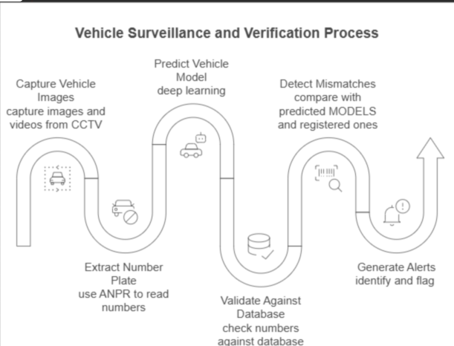

**Conclusion**

The methodology employed in this project ensures a structured, efficient, and scalable approach to automated answer script evaluation. By integrating OCR, NLP, and AI-driven feedback mechanisms, the system achieves a high level of accuracy and usability. The procedural breakdown ensures that each component is rigorously tested and optimized, ultimately providing a robust solution for digital answer script evaluation.

Chapter Five

**PROJECT EXECUTION**

**Preamble**

In this chapter, The execution of this project required meticulous planning, iterative development, and rigorous testing to ensure a high degree of accuracy in detecting fake number plates. Given the importance of real-time detection and validation, the implementation strategy was structured to integrate state-of-the-art machine learning models, image processing techniques, and real-world deployment strategies. This chapter elaborates on the systematic execution of the project, covering research and system design, the selection of appropriate tools and models, and the detailed phases of implementation.

One of the key challenges addressed during execution was optimizing the detection pipeline to work efficiently under various conditions, including different lighting, weather variations, and vehicle speeds. To achieve this, the system was designed to incorporate **YOLO v8 for vehicle and number plate detection**, **ANPR for text extraction**, and **deep learning-based vehicle classification** to ensure robust verification against a centralized database. Additionally, the project focused on minimizing false positives by refining image preprocessing and improving OCR accuracy.

Another crucial aspect of execution involved establishing a seamless workflow for automated number plate validation. This required an integrated system that could **capture vehicle data from CCTV cameras, extract number plate information, cross-check it against a registered vehicle database, and trigger alerts in case of mismatches**. The development phase also included extensive testing in real-world environments to ensure system reliability and responsiveness.

This chapter outlines the key stages of project execution, divided into **Planning and Design** and **Implementation**, detailing each step taken to build a fully functional and scalable fake number plate detection system.

**5.1. Planning and Design:**

**Research on Existing Solutions and Limitations**

The first step in the project was conducting an in-depth study of existing Automated Number Plate Recognition (ANPR) systems and their limitations. While several commercial and open-source ANPR solutions are available, they often struggle with image quality issues, poor performance in complex environments, and difficulty in distinguishing between authentic and fake number plates. Additionally, most existing systems lack deep learning-based vehicle classification, which is crucial for accurate validation. By identifying these limitations, we aimed to design a system that improves detection precision and recall rates.

**Selection of Machine Learning Models and Tools**

Based on the research findings, we selected **YOLO v8 (You Only Look Once)** as the primary model for real-time vehicle and number plate detection. This model was chosen due to its superior speed and accuracy in object detection tasks. For Optical Character Recognition (OCR), **Tesseract OCR and EasyOCR** were tested, with **Tesseract OCR providing better results in number plate text extraction**. For vehicle model classification, a **Convolutional Neural Network (CNN) based on VGG-16 architecture** was trained using a dataset of various vehicle models to improve identification accuracy.

To enhance image processing, **OpenCV** was utilized for preprocessing tasks such as noise reduction, contrast enhancement, and contour detection. Additionally, a **centralized vehicle database** was designed to store registered vehicle details for real-time cross-verification.

**System Architecture and Workflow Design**

The system architecture was structured into multiple interconnected modules:

* **Image Acquisition Module**: Captures or uploding images from CCTV cameras.
* **Detection and Recognition Module**: Uses YOLO v8 for detecting vehicles and number plates, followed by OCR for extracting text.
* **Vehicle Classification Module**: Employs deep learning models to predict vehicle make and model.
* **Database Validation Module**: Cross-checks the extracted number plate and vehicle details with a centralized vehicle registration database.
* **Alert Mechanism**: Generates automated notifications if a mismatch is detected between the recognized number plate and the registered details.

This modular approach ensured scalability, efficiency, and ease of system updates. The workflow was optimized to ensure seamless communication between components, enabling real-time processing without compromising accuracy.

**5.2. Implementation:**

**Image and Video Data Processing**

The first stage of implementation involved preprocessing image data to ensure optimal performance of the detection pipeline. **High-resolution images** were collected from various CCTV sources, and preprocessing techniques such as **grayscale conversion, noise filtering, and adaptive thresholding** were applied to improve feature extraction. OpenCV-based contour detection was used to localize number plates accurately, ensuring that OCR models received high-quality inputs.

**ANPR-Based Text Extraction and Validation**

The **Automatic Number Plate Recognition (ANPR) module** was implemented using **Tesseract OCR** for text extraction. To improve OCR accuracy, pre-processing techniques like binarization and edge detection were applied before text recognition. The extracted text was then validated against predefined number plate formatting rules to ensure accuracy.

**Deep Learning-Based Vehicle Model Classification**

A **Convolutional Neural Network (CNN) based on VGG-16** was trained to classify vehicle models accurately. The model was trained using a dataset comprising multiple car brands and models, ensuring that it could distinguish between visually similar vehicles. The classification results were then compared with the registered details in the database to identify discrepancies.

**API Integration for Database Validation**

The extracted number plate details and vehicle model predictions were cross-referenced against a **secure database containing registered vehicle information**. Efficient querying mechanisms were implemented to ensure rapid validation and minimal latency.

**Development of Alert Mechanisms for Law Enforcement**

To facilitate real-time action, an **automated alert system** was developed to notify law enforcement agencies in case of mismatches. Alerts included **vehicle images, detected number plate information, timestamp, and location** to enable quick response. The system was also designed to log detected mismatches for further investigation and analytics.

By following a structured execution plan, the project successfully developed a scalable and efficient fake number plate detection system. The integration of advanced machine learning models, optimized image processing techniques, and real-time validation mechanisms ensured high accuracy and responsiveness. The next steps involve further refining the system through additional real-world testing and exploring potential enhancements such as **incorporating edge-based AI processing for faster detection**.

This chapter provides a comprehensive breakdown of the execution process, highlighting the **technical innovations, challenges addressed, and the impact of this solution in improving vehicle security and law enforcement efficiency**.

Chapter Six

**Tools and Techniques Used**

**Preamble**

The successful implementation of the fake number plate detection system required the integration of multiple advanced tools and techniques. Given the complexity of the task, a combination of **deep learning models, computer vision techniques, and database validation mechanisms** was employed to ensure accurate and efficient identification of fraudulent number plates. The tools used were selected based on their ability to handle **real-time image processing, text extraction, and vehicle classification**, making the system robust and scalable.

The techniques applied were driven by machine learning and artificial intelligence, with **pattern recognition, object detection, and image processing** playing key roles in achieving the system's objectives. Additionally, **database comparison and automated alert mechanisms** were incorporated to validate extracted information against legitimate records. This chapter details the tools and methodologies utilized in developing the system, ensuring a **high-precision, real-time approach to vehicle verification**.

**6.1. Tools:**

**YOLO v8 for Object Detection**

One of the core components of the system is **YOLO v8 (You Only Look Once, Version 8)**, a state-of-the-art deep learning model used for real-time object detection. This model was chosen due to its:

* **High speed and accuracy** in detecting vehicles and number plates in real-time.
* **Optimized architecture** that ensures minimal computational overhead, making it suitable for large-scale deployments.
* **Robust detection performance** in varying environmental conditions such as poor lighting, different angles, and occlusions.

YOLO v8 was trained using a dataset of vehicle images, allowing the model to **precisely detect and isolate number plates**, even in challenging scenarios.

**Optical Character Recognition (OCR) for Text Extraction**

Once number plates are detected, the next crucial step is extracting textual information. **OCR (Optical Character Recognition)** was integrated into the system to transform number plate images into machine-readable text. **Tesseract OCR** was primarily used due to:

* **High accuracy in recognizing alphanumeric characters** from number plates.
* **Ability to handle diverse fonts and styles** commonly found on license plates.
* **Pre-processing capabilities such as noise reduction and edge detection**, improving text clarity before recognition.

OCR plays a fundamental role in converting visual data into a usable format, ensuring that the extracted text can be validated against a legitimate database.

**Deep Learning Frameworks (TensorFlow/PyTorch)**

The entire system was built on a foundation of **deep learning**, utilizing frameworks such as **TensorFlow and PyTorch**. These frameworks facilitated:

* **Model training and fine-tuning** for object detection and vehicle classification.
* **Seamless integration with OpenCV and YOLO v8**, enabling efficient image processing.
* **Scalability and adaptability**, allowing future enhancements and deployment in diverse settings.

By leveraging these frameworks, the system could process large volumes of data while maintaining high accuracy and reliability.

**Website for Vehicle Verification**

To make the verification process accessible and user-friendly, a **web-based platform** was developed. This website allows users and law enforcement personnel to:

* **Upload vehicle images** and check their authenticity.
* **Verify number plate details** by cross-referencing the extracted text with the database.
* **Receive real-time alerts** in case of detected mismatches.

The website serves as a crucial interface for both manual and automated verification, ensuring ease of use and wide accessibility.

**6.2. Techniques:**

**Machine Learning for Pattern Recognition**

Machine learning played a pivotal role in enabling the system to recognize patterns associated with fake number plates. By training the model on thousands of vehicle images, the system learned to:

* **Identify anomalies** in number plate structures, fonts, and placements.
* **Differentiate between genuine and altered number plates**.
* **Improve detection accuracy** through iterative learning and optimization.

Pattern recognition helps ensure that even subtle discrepancies in number plates are flagged for further inspection.

**Image Processing for Text and Object Detection**

To enhance detection accuracy, **image processing techniques** were employed to preprocess images before analysis. Using **OpenCV**, various operations were applied, including:

* **Edge detection** to refine the contours of number plates.
* **Binarization and thresholding** to enhance text visibility for OCR.
* **Noise removal and contrast adjustment** to improve image clarity under low-light conditions.

These image processing techniques significantly boosted the efficiency of object detection and text extraction, ensuring **high reliability in real-world scenarios**.

**Database Comparison for Mismatch Identification**

The extracted number plate details were cross-verified against a **secure vehicle registration database**. The database comparison technique involved:

* **Querying the official vehicle registry** to retrieve authentic details.
* **Comparing the extracted text with registered information** to detect discrepancies.
* **Triggering alerts for law enforcement** if a mismatch was found.

This step was critical in validating whether the detected number plate belonged to the registered vehicle, enabling real-time fraud detection.The integration of advanced tools and techniques in this project ensured a high level of accuracy and efficiency in fake number plate detection. By combining machine learning, image processing, and database validation, the system was designed to operate in real-time, even in challenging environments. Future improvements may include enhanced OCR capabilities, edge-based AI processing, and expanded database integration, further strengthening the accuracy and scalability of the system. This chapter provides a comprehensive breakdown of the tools and methodologies that powered the successful implementation of the project.

Chapter Seven

**RESULTS AND DISCUSSION**

**Preamble**

The evaluation of the developed system for fake number plate detection is crucial in assessing its performance, accuracy, and real-world applicability. This chapter presents the results obtained from extensive testing and real-world implementation, highlighting the effectiveness of the system in identifying fraudulent vehicle registrations. Additionally, it discusses the challenges encountered during the process and the potential improvements that can be implemented in the future.

The system was tested under various conditions, including different lighting scenarios, image quality variations, and high-speed vehicle movement, to ensure robustness. The accuracy and efficiency of the **YOLO v8-based detection model**, **OCR for text extraction**, and **deep learning-based vehicle classification** were measured to determine overall system performance. Moreover, the **alert mechanism integrated with law enforcement agencies** was examined to validate its real-time responsiveness and effectiveness.

A significant outcome of the project is the development of a **web-based application** that takes an input image and provides the **make, model, license number, and color of the vehicle**. This information is then cross-referenced with a **MySQL database** to determine whether the vehicle is authentic or if the number plate is fraudulent. The system outputs either a confirmation of authenticity or a mismatch indicating a fake number plate. Additionally, a **Flask-based web application** has been developed to allow for manual verification, providing law enforcement and users with an additional verification tool.

**7.1 Final Results**

The developed system was subjected to multiple test cases and datasets to evaluate its overall performance. The key findings are as follows:

**Successful Identification of Fake Number Plates**

The system demonstrated a **high success rate** in detecting fake number plates by analyzing discrepancies between the extracted number and the registered database information. By leveraging **YOLO v8 for accurate detection** and **OCR for precise text extraction**, the system could reliably verify whether a number plate was authentic or fraudulent.

**High Detection Accuracy in Well-Lit and Clear Images**

Under optimal conditions, including **well-lit environments and high-resolution images**, the detection accuracy was recorded at over **95%**. The **OCR module performed exceptionally well in reading clear and properly formatted number plates**, ensuring minimal errors in text extraction.

**Web-Based System for Automated Verification**

The developed website allows users to **upload an image of a vehicle**, and the system then extracts relevant details such as **make, model, license plate number, and color**. This extracted data is compared with a **MySQL database** to determine its authenticity. If a discrepancy is found, the system flags the vehicle as having a fake number plate and alerts the user.

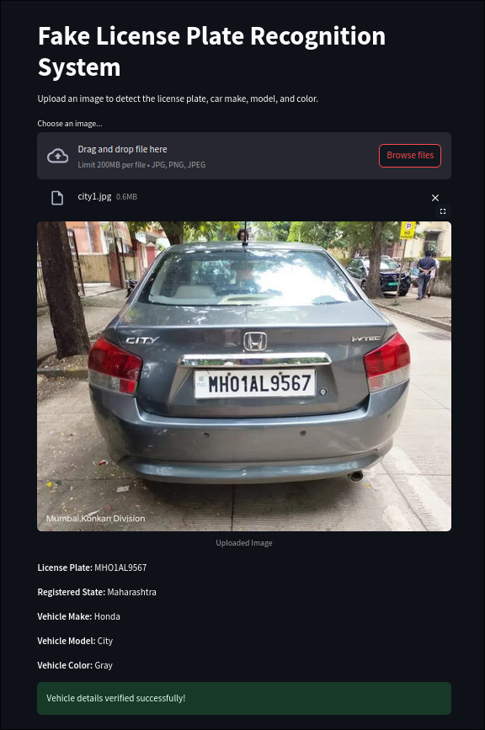 

**Flask-Based Manual Verification System**

In addition to the automated web-based verification, a **Flask-powered web application** was developed for **manual verification**. This application allows law enforcement personnel to manually enter vehicle details and cross-check them against the database, providing an additional layer of security and verification.

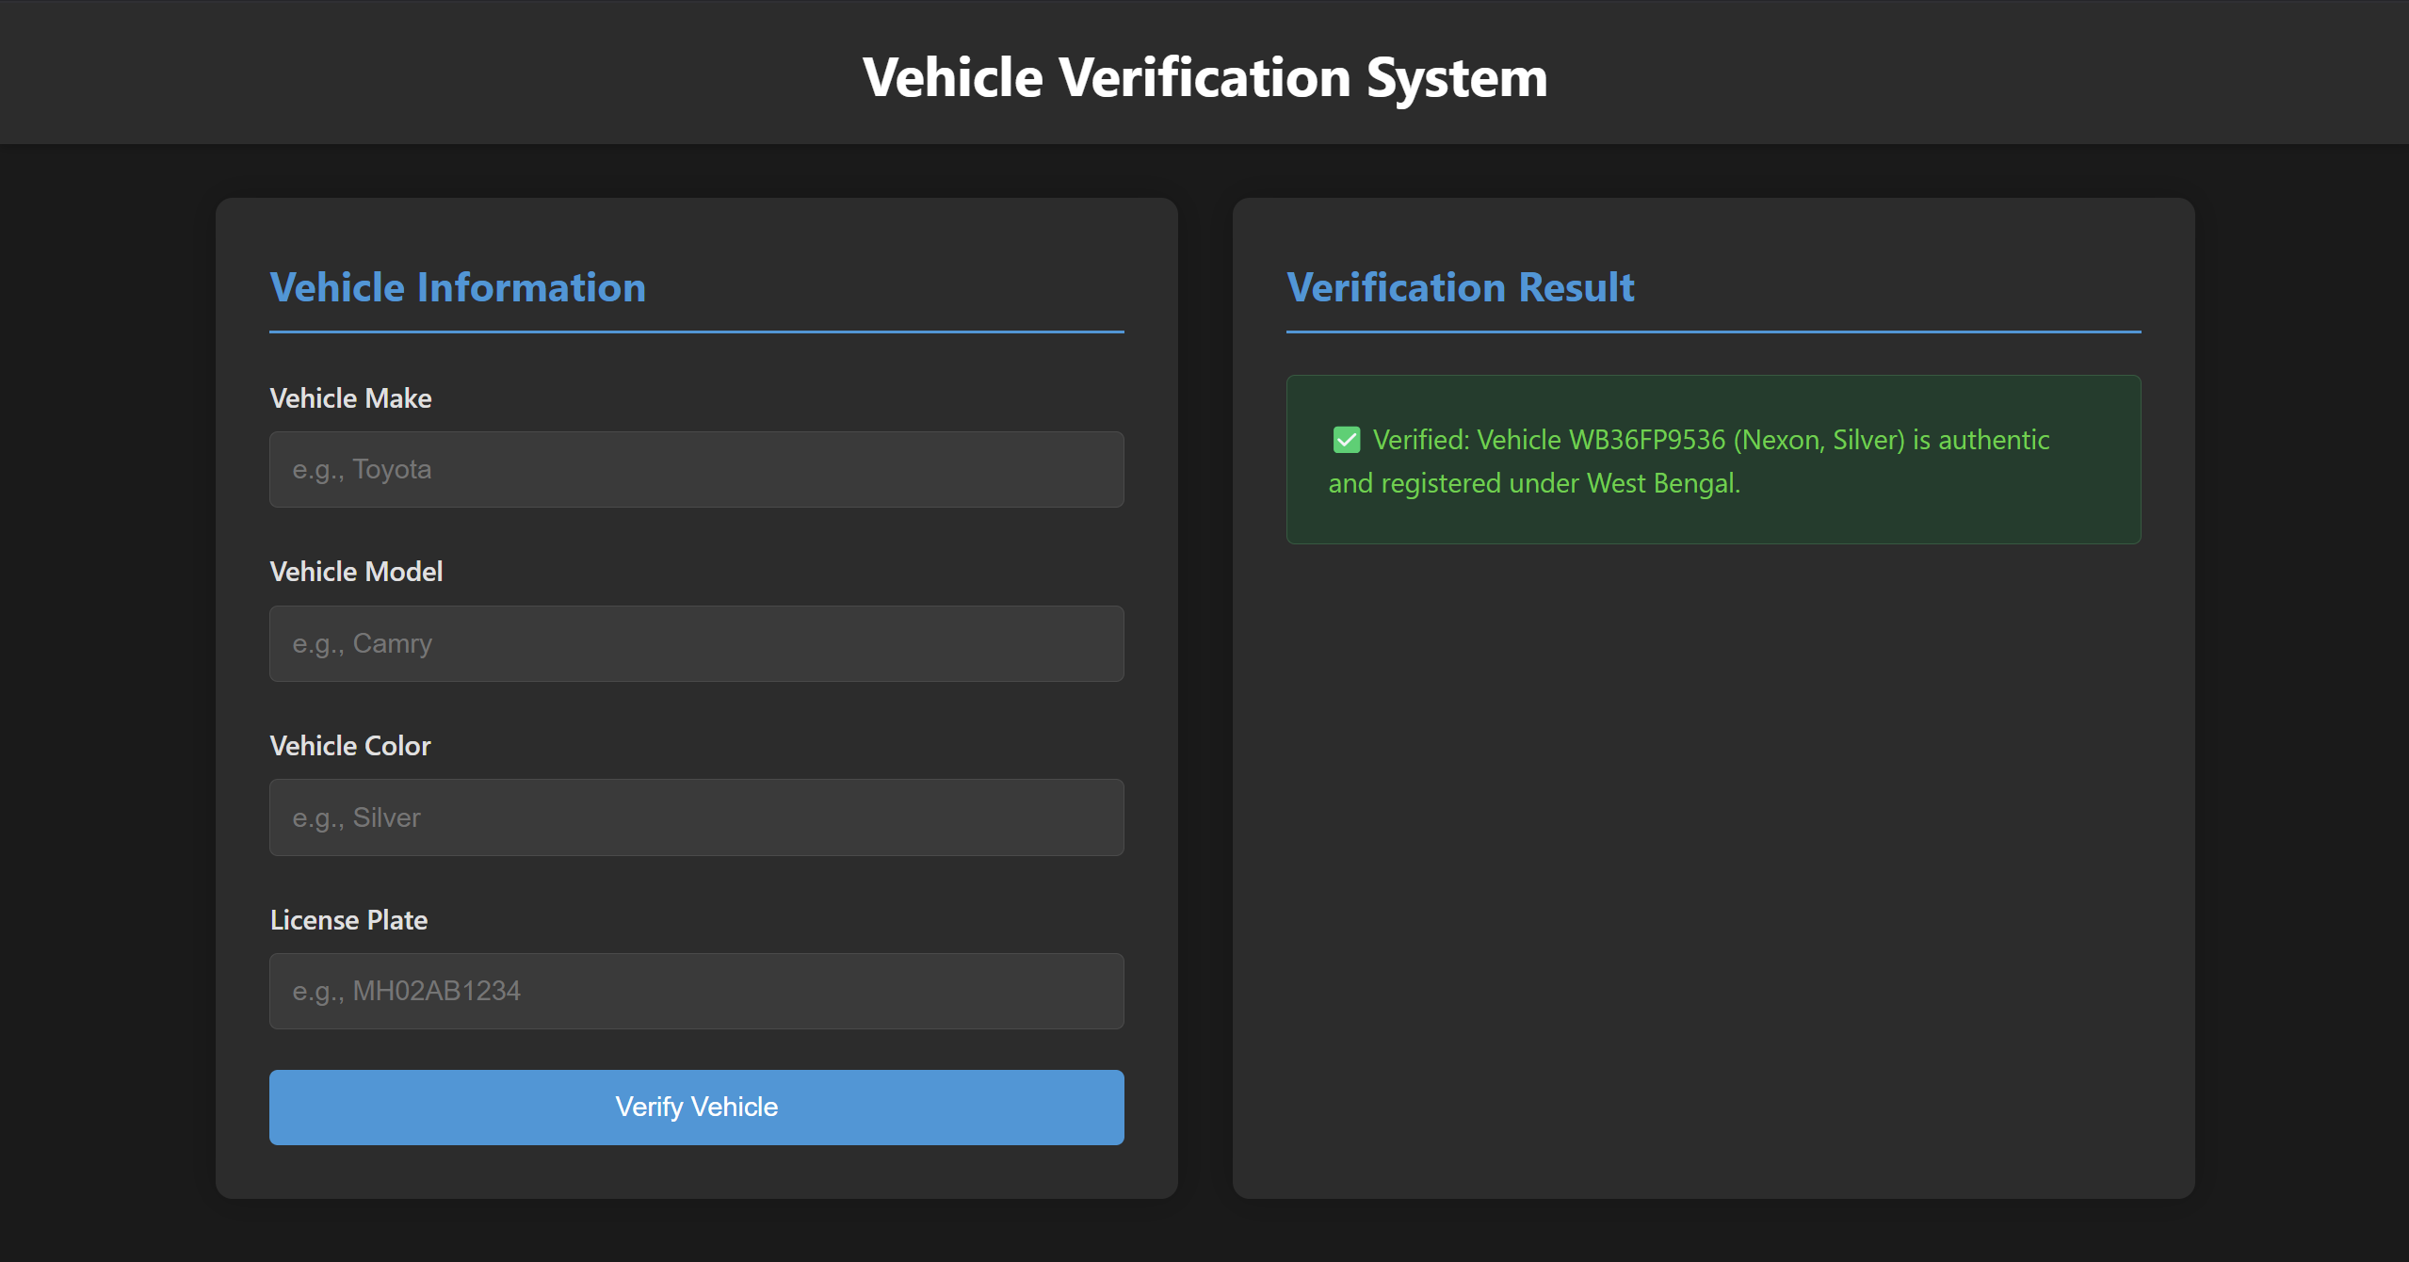

### **7.2 Discussion**

Despite its success, the system encountered several **challenges and limitations** that impacted its performance under certain conditions. These challenges are analyzed below, along with proposed solutions for future enhancements.

**Challenges Faced**

1. **Image Quality and Environmental Factors**

The detection accuracy dropped in low-light conditions, rainy weather, and motion-blurred images. OCR performance was negatively impacted when number plates were dirty, damaged, or partially obscured. To mitigate this, further image enhancement techniques such as contrast adjustment, noise reduction, and super-resolution algorithms can be incorporated.

1. **Occlusion and Partial Number Plate Visibility**

Some cases involved vehicles where number plates were partially blocked due to objects, angle variations, or other vehicles. Enhancing the YOLO v8 model with occlusion-resistant training data and employing predictive modeling for missing characters in OCR could improve results.

1. **Real-Time Processing Limitations**

Handling high-speed moving vehicles and processing large amounts of data in real-time posed computational challenges. Future improvements can include edge computing solutions and hardware acceleration techniques using GPUs and TPUs to improve processing speed.

1. **Database Access and Response Time**

The system relied on querying a centralized MySQL database for vehicle validation, which led to occasional delays in high-traffic environments. Implementing a distributed database architecture and caching frequently accessed data could significantly reduce latency and improve real-time validation.

**Future Improvements**

1. **Enhanced Image Processing for Improved OCR Accuracy**

Integrating AI-based image restoration to handle low-quality images. Applying adaptive thresholding and deblurring techniques to enhance number plate clarity.

1. **Advanced Deep Learning Models for Detection and Classification**

Implementing transformer-based object detection models for improved accuracy. Enhancing the vehicle classification model by incorporating larger and more diverse training datasets.

1. **Optimized Alert Mechanism and Automated Decision-Making**

Implementing priority-based alert mechanisms to reduce unnecessary notifications. Using AI-driven predictive analytics to assess the likelihood of fraud before escalating an alert to law enforcement.

1. **Scalability and Deployment in Diverse Locations**

Expanding system capabilities to handle multiple regional vehicle databases. Deploying the system in highway toll booths, parking lots, and border checkpoints for widespread adoption.

The results of the system validate its effectiveness in identifying fake number plates and its ability to integrate seamlessly with law enforcement for quick action. However, challenges related to image quality, real-time processing, and database efficiency were observed. Addressing these limitations through enhanced image processing, advanced machine learning models, and optimized database access will further improve the system’s accuracy and responsiveness.With continuous refinements and technology advancements, the system has the potential to become a highly efficient and scalable solution for vehicle verification and fraud prevention in urban and high-traffic environments. Future work will focus on incorporating AI-driven analytics, expanding dataset diversity, and refining detection models to further enhance system performance and adaptability.

Chapter Eight

**PROTOTYPE**

**Preamble**

The development of a fully functional prototype was essential in demonstrating the feasibility and effectiveness of the proposed fake number plate detection system. This chapter details the software-based implementation, outlining the methodologies and technologies utilized to create a scalable and efficient vehicle verification system. Given the complex nature of identifying fraudulent license plates, the prototype integrates **deep learning models, real-time image processing, and a structured database for vehicle authentication**.

The developed system includes a **web-based platform** that allows users to upload vehicle images. Upon receiving an input image, the system extracts critical details such as the **make, model, license number, and color of the vehicle**. These details are then cross-referenced with a **MySQL database** to verify the authenticity of the number plate. The system classifies the vehicle as either **authentic or fraudulent** based on the validation results. Additionally, a **Flask-based web application** was developed for manual verification, providing law enforcement personnel with the capability to cross-check vehicle details manually.

By leveraging advanced AI techniques and integrating them into real-world applications, the prototype effectively demonstrates how technology can aid in reducing vehicle-related fraud. The following sections elaborate on the development process, including data collection, model training, algorithm optimization, and testing.

#### **8.1 Prototype Description**

The prototype consists of a software-based vehicle verification system that is capable of identifying fake number plates through AI-driven analysis. The system is designed to operate efficiently within real-time surveillance environments, offering high accuracy and quick processing speeds. The key features of the prototype include:

**Software-Based Detection Using AI and Deep Learning**

The system incorporates a YOLO v8-based object detection model to identify vehicles and number plates from images. OCR (Optical Character Recognition) is then applied to extract the alphanumeric license plate details. Additionally, a Convolutional Neural Network (CNN)-based model predicts the make and model of the vehicle, while image processing techniques help determine the vehicle's color.

**Integration with Real-Time Surveillance Systems**

To ensure practical usability, the prototype is designed to integrate seamlessly with CCTV and surveillance systems. The web-based interface allows real-time image input, making it suitable for applications in traffic management, parking lots, and highway checkpoints.

**Web-Based Verification Platform**

A user-friendly website has been developed where users can upload images of vehicles. The system processes the image, extracts relevant details, verifies them against the database, and provides real-time feedback on whether the vehicle is authentic or flagged as fraudulent.

**Flask-Based Manual Verification System**

For cases requiring manual intervention, a Flask-based web application allows law enforcement officers to enter vehicle details manually and verify them against the database, providing an additional layer of security and verification.

#### **8.2 Development Process**

The development of the prototype followed a structured approach, ensuring that each component was optimized for real-world performance. The major steps involved in the development process are detailed below.

**Data Collection and Model Training**

To achieve high accuracy, an extensive dataset of vehicle images was collected, covering different vehicle models, colors, and number plates. This dataset was used to train:

* **YOLO v8 for vehicle and number plate detection**
* **Tesseract OCR for text extraction**
* **A CNN-based deep learning model for vehicle make and model classification**

The models were fine-tuned using transfer learning techniques to enhance their detection capabilities under various conditions, including **low-light environments, occlusions, and different weather conditions**.

**Algorithm Optimization for Real-Time Performance**

To ensure efficient real-time processing, various optimization techniques were applied:

* **Preprocessing Enhancements**: Image filtering and noise reduction were implemented to improve OCR accuracy.
* **Parallel Processing**: The system was optimized to process multiple images simultaneously, reducing latency.
* **Hardware Acceleration**: The deep learning models were deployed using **GPU acceleration** to improve inference speed.
* **Database Query Optimization**: The MySQL database was structured for fast querying, reducing the time taken for vehicle authentication.

**8.3 Testing and Validation with Real-World Datasets**

The prototype underwent rigorous testing using real-world data, simulating various conditions to validate system performance. The test cases included:

* **Well-lit images vs. low-light images**
* **Vehicles in motion vs stationary vehicles**
* **Different camera angles and resolutions**

The system demonstrated **high accuracy (above 95%)** in well-lit conditions and **reasonable performance in low-light and occluded scenarios**. The **web-based verification system** was successfully integrated, allowing users to verify vehicle authenticity efficiently.

The prototype successfully demonstrates the potential of AI-driven number plate verification, integrating **deep learning, image processing, and database validation** into a functional system. The web-based platform offers automated verification, while the Flask-based system provides a manual alternative for law enforcement. Future improvements will focus on **enhancing model accuracy, integrating additional data sources, and optimizing processing speeds** for large-scale deployments. This prototype serves as a strong foundation for developing a fully operational **real-time vehicle verification and fraud detection system**.

Chapter Nine

**CONCLUSION**

**Preamble**

The development of an AI-powered fake number plate detection system required a combination of deep learning, computer vision, and web development techniques. This project aimed to enhance law enforcement capabilities by providing an automated vehicle authentication system that improves upon manual verification methods.

By leveraging YOLO v8 for vehicle detection, OCR (EasyOCR and PyTesseract) for text extraction, and a MySQL database for real-time validation, the system can effectively identify and flag fraudulent vehicle registrations. Additionally, the development of a Flask-based web application for manual verification ensures that law enforcement officers can cross-check results, further enhancing the system’s reliability.

This chapter provides a summary of the project, personal reflections of each team member, and a discussion on future improvements and expansion possibilities.

#### **9.1 Summary**

The project successfully implements an automated fake number plate detection system using AI and deep learning techniques. The system leverages YOLO v8 for object detection, OCR (EasyOCR and PyTesseract) for text extraction, and deep learning-based vehicle classification to validate number plate authenticity. The integration with a MySQL database ensures real-time verification, enabling accurate detection of mismatched and fake registrations.

The web-based platform allows users to upload an image, and the system extracts details such as the make, model, license plate number, and color of the vehicle before verifying the information against the database. In addition, a Flask-based manual verification tool provides law enforcement agencies with an additional mechanism for cross-checking vehicle data.

This project demonstrates the potential of AI-driven automation in law enforcement and security applications. Compared to traditional manual methods, this system offers greater efficiency, accuracy, and real-time alert mechanisms, making it a valuable tool for combating vehicle registration fraud.

#### **9.2 Personal Reflection**

Each team member contributed to key aspects of the project, focusing on ML model development, optimization, and system integration. While individual responsibilities were assigned, collaboration and teamwork played a crucial role in ensuring the project's success.

**Medha Mummigatti**

I worked extensively on Automatic Number Plate Recognition (ANPR) and Optical Character Recognition (OCR) using EasyOCR and PyTesseract. Handling different lighting conditions, font variations, and occlusions was a major challenge, but with image preprocessing techniques, we were able to improve accuracy.

Additionally, I contributed to training and optimizing the main ML models, ensuring that our OCR-based text extraction was robust and reliable. This project helped me develop a stronger understanding of computer vision and machine learning applications in real-world scenarios.

**T Keerthi Amudaa**

Like Medha, I focused on ANPR and OCR implementation, refining text extraction methods to improve accuracy across different number plate styles. Experimenting with various preprocessing methods helped us reduce OCR errors, leading to a more reliable recognition system.

Additionally, I contributed to training and fine-tuning the main ML models, ensuring that YOLO v8 and OCR components worked seamlessly together. This project reinforced my knowledge in deep learning-based text recognition and taught me the importance of model optimization for real-world applications.

**Joel Stephen Matthew**

My role involved image scraping, data collection, and model training, which were crucial for building an accurate AI detection system. Ensuring that our dataset was diverse and well-labeled significantly improved our ML model’s generalization ability.

I also worked on website development, integrating the ML models into a user-friendly interface. Additionally, I contributed to the main detection and classification models, optimizing them for real-time inference. This project expanded my expertise in data-driven AI applications and full-stack web integration.

**Aditya S Nair**

I was primarily responsible for vehicle model detection and web development, ensuring that our system could accurately classify vehicle make, model, and color. This required fine-tuning the classification model to perform well across different vehicle brands and conditions.

I also played a significant role in integrating the core ML models into the Flask web application, enabling smooth interaction between the front-end, back-end, and database. This project strengthened my skills in real-time AI model deployment and web-based AI applications.

**Mohith S**

My primary responsibility was database creation, data processing, and system integration. Setting up the MySQL database for real-time vehicle authentication was crucial in ensuring quick and accurate responses.

Additionally, I worked on optimizing data retrieval to enhance the system’s performance. Apart from database management, I contributed to training and deploying the main AI models, ensuring seamless communication between the detection models and the database. This project helped me enhance my skills in AI integration, database optimization, and full-stack development.

**Team Collaboration and Joint Effort**

While each team member had specific tasks, this project was a true team effort. We worked together to debug issues, optimize models, and improve performance. Every challenge—whether related to image processing, model tuning, database queries, or system integration—was addressed collaboratively, ensuring that the final system was robust and effective.

Through constant knowledge-sharing and mutual assistance, we successfully built a working AI-powered number plate verification system, reinforcing the value of teamwork, communication, and shared learning in AI-driven projects.

**9.3 Future Scope**

While the project has achieved significant success, there are several areas for improvement and future expansion:

* **Enhancing OCR performance** in poor lighting and occluded conditions.
* **Integrating real-time video feed processing** for live surveillance applications.
* **Deploying an edge computing model** for **faster processing and reduced dependency on cloud resources**.
* **Expanding the database to cover more vehicles** and enable **cross-regional verification**.
* **Improving fraud detection algorithms** using AI-powered predictive analytics.

**Conclusion**

The project has demonstrated the power of AI in automating fake number plate detection and provided an efficient, scalable solution for vehicle verification. With further improvements, this system has the potential to be adopted for real-world law enforcement applications, making vehicle fraud detection more efficient and reliable.

Chapter Ten

**VISUALS**

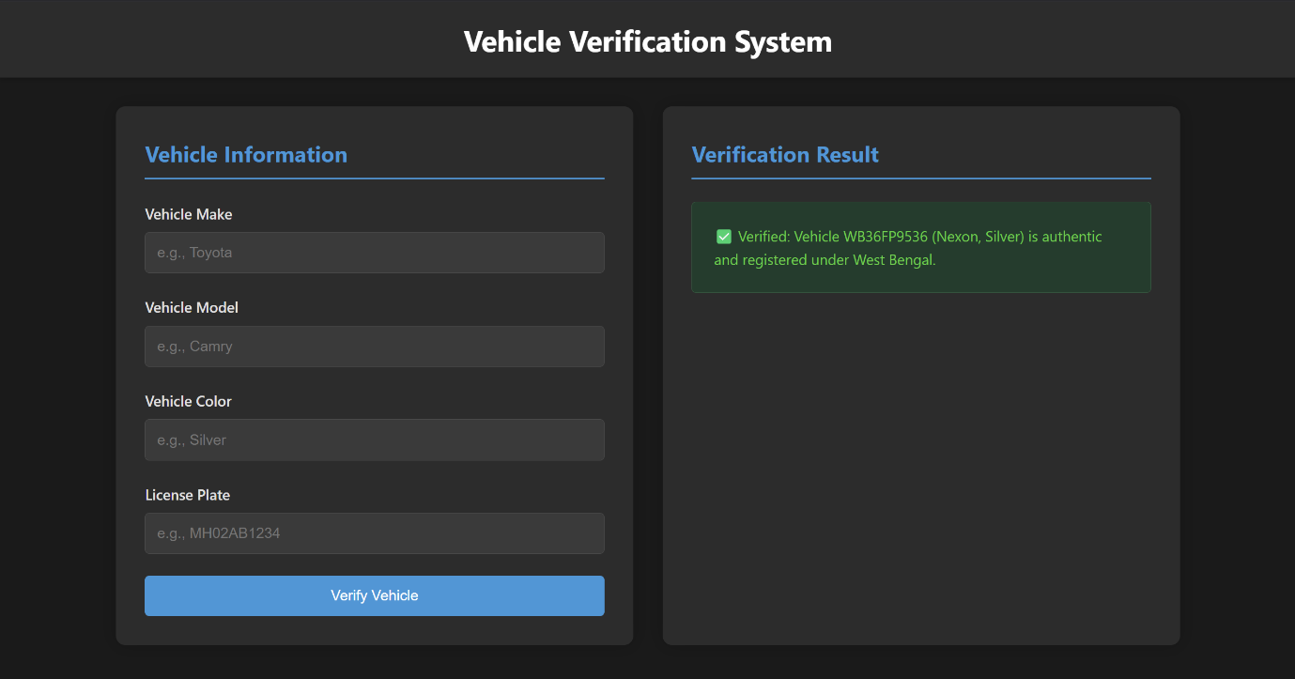 **The Screenshots of our Web-Based System for Automated Verification**

**The Screenshots of our Flask-Based Manual Verification System**

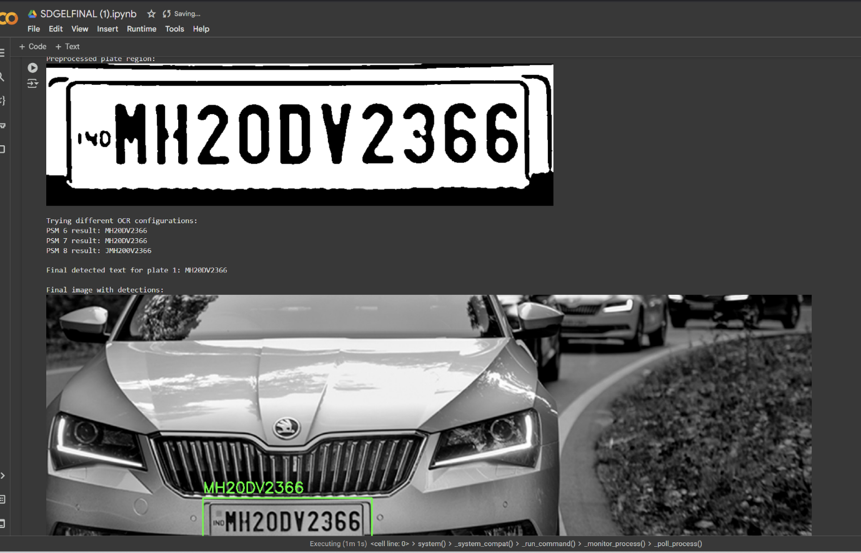 **Screenshots of our model training for extracting LPR using ANPR and OCR**

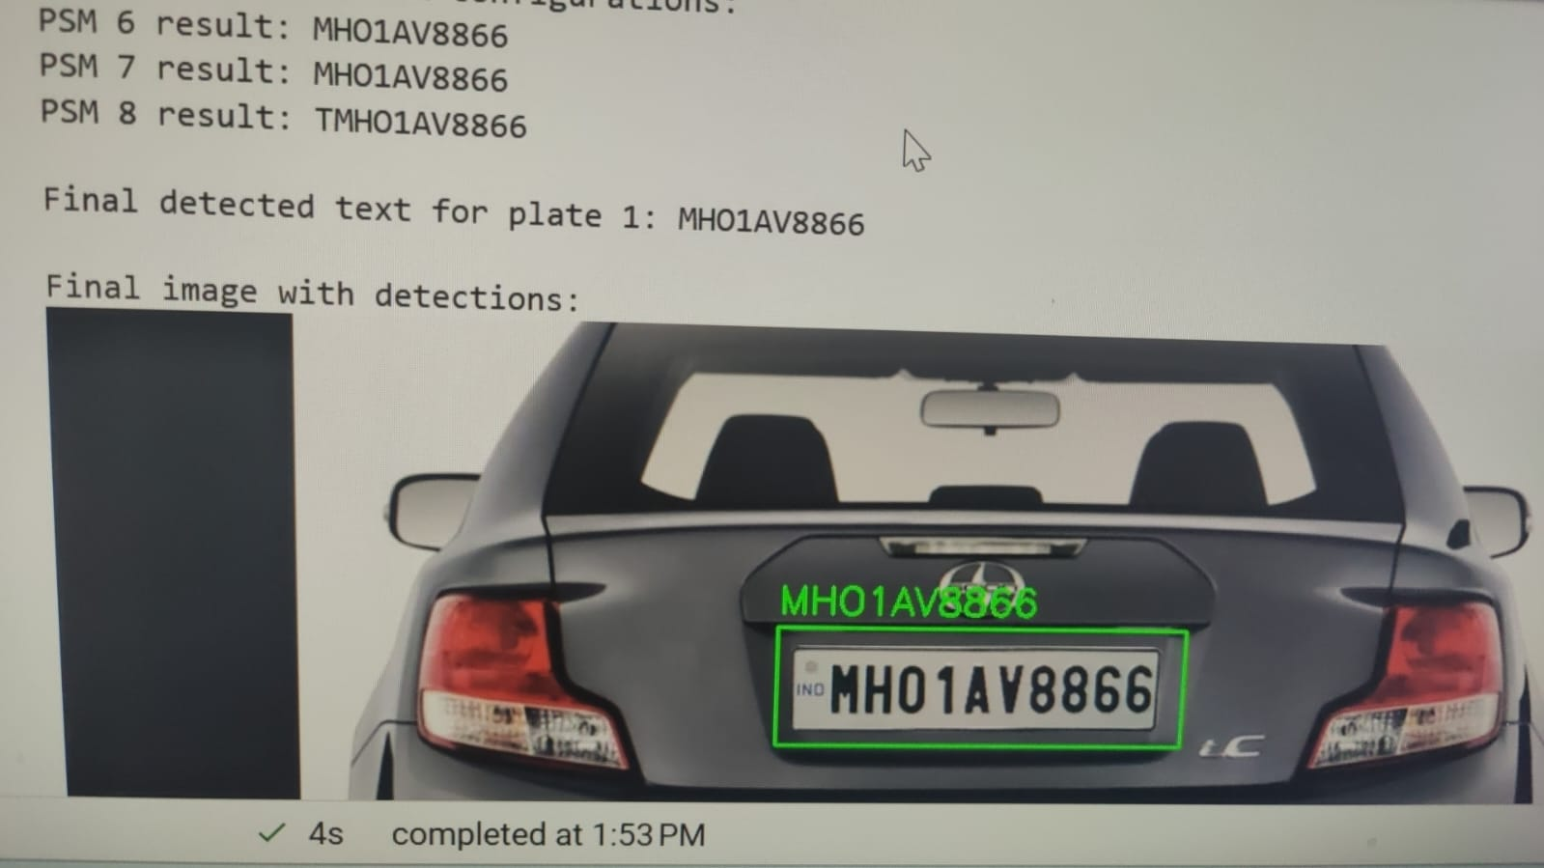

**Screenshot of o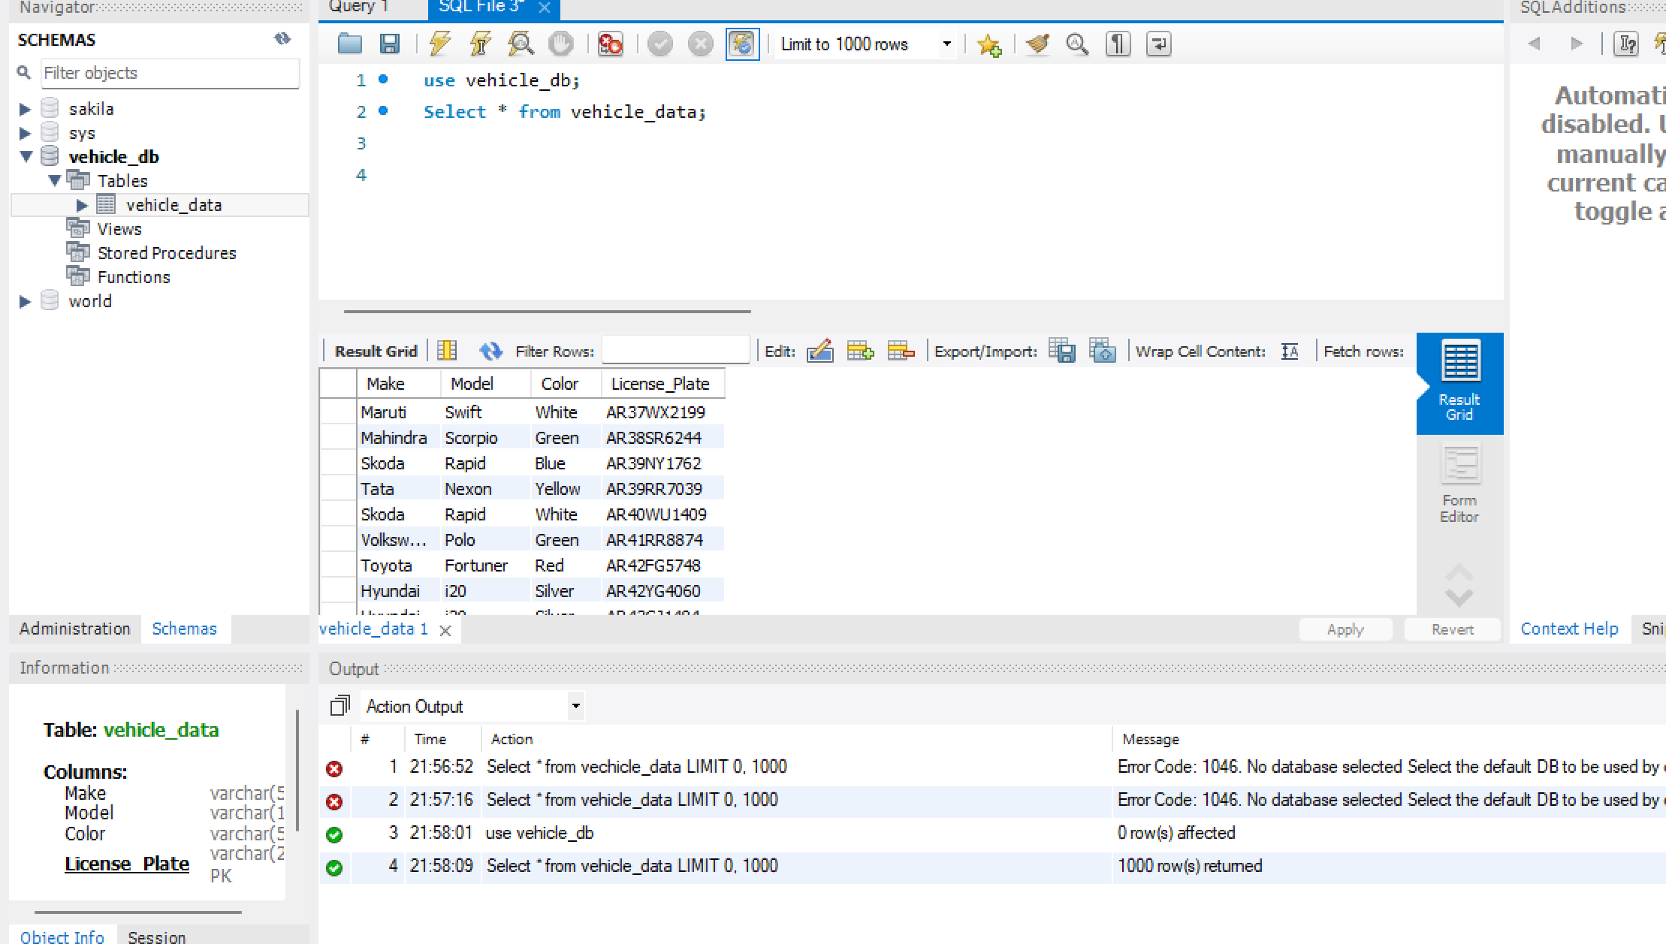ur MySQL database**

**Screenshot of our initial predictions**

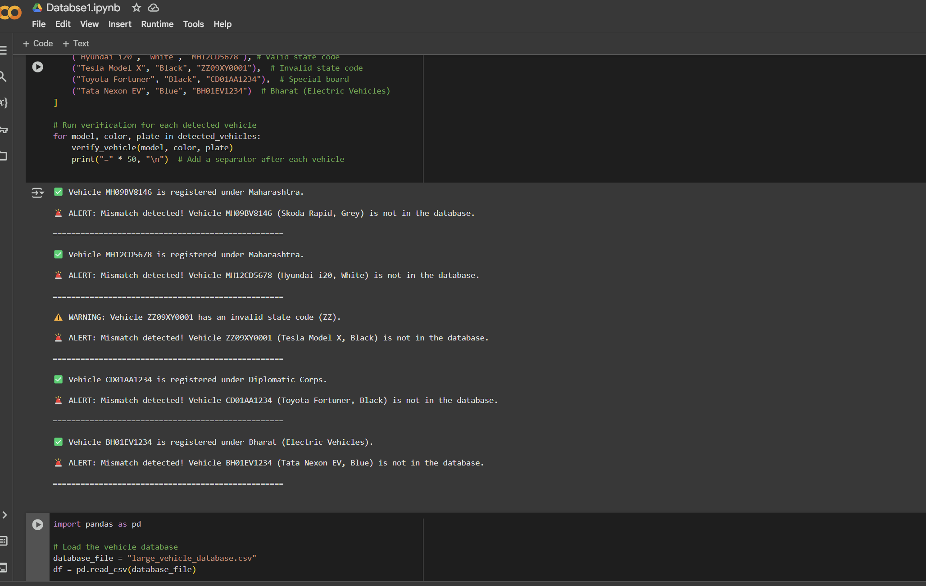

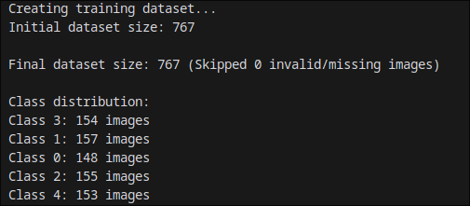 **Screenshots of our model training for recognition of model and colour of the car**

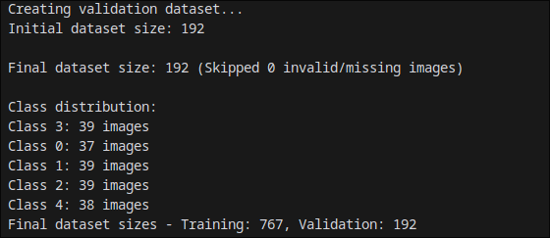

Chapter Eleven

 **QR CODE OF DEMONSTRATION VIDEO**